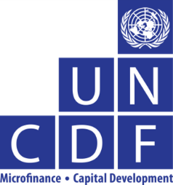

Guest Speakers Bios

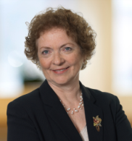

  - Joyce Lehman

Joyce has been working in international economic development for the past 15 years, most recently as a Program Officer with the Bill & Melinda Gates Foundation based in Seattle, Washington. While there she managed a grant portfolio of over US $100 million that funded projects throughout the developing world, including grant funding to support community based savings groups, savings-focused MFIs, and mobile payment platforms in Bangladesh and Pakistan. From 2003 through 2007 she spent most of her time in Afghanistan working with the World Bank, USAID and other organizations to establish and support a microfinance sector there. Ms. Lehman is a frequent speaker at microfinance industry conferences and was a faculty member at leading Microfinance Training Institutes held in the US, Europe and South Africa. Currently, she is an independent consultant with a focus on financial inclusion, serving as a technical advisor to foundations and other donor organizations from her home in Keene, New Hampshire.
Prior to her international work, Ms. Lehman was a high school mathematics teacher, served business clients in private practice as a Certified Public Accountant, and taught university level business courses. She holds a Bachelor of Arts Degree from Eastern Mennonite University in Harrisonburg, Virginia and a Master’s Degree from the Bentley College Graduate School of Business in Waltham, Massachusetts.
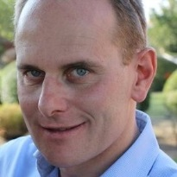

  - Francois Coupienne

Francois joined the Mobile Money for the Poor (MM4P) programme of UNCDF in January 2013. He is responsible for developing and overseeing the work in 5 countries (Liberia, Malawi, Nepal, Lao and Uganda) and support the development of additional countries in Africa and Asia. François brings a wealth of experience in branchless and mobile banking. His career includes work related to distribution in the retail sector which he then translated into his work with BNP Paribas Fortis looking at alternative payment channels – internet, phone and electronic vouchers. From 2008 to 2012, he has worked on the development and implementation of branchless and mobile banking efforts in several countries in Africa including those led by banks and MNOs. Most recently he has worked and assisted in the development of agent networks including working with MFIs.

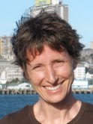

  - Cheryl Frankiewicz

Cheryl Frankiewicz has been working in microfinance for twenty years, focusing on management, product marketing and capacity building. She is the co-author of two International Labor Organization (ILO) publications, Making Microfinance Work: Managing for Improved Performance and Making Microfinance Work: Managing Product Diversification. As a Master Trainer for the ILO’s International Training Centre, she led the design of a training curriculum and certification process through which the Making Microfinance Work program is disseminated through a network of 100+ local trainers in nine languages. Ms. Frankiewicz is a MicroSave-certified service provider in the areas of market research, process mapping and risk analysis, product marketing, strategic marketing and customer service. She has been a faculty member of the Boulder Microfinance Training Program since 2007 and has served on the Curriculum Advisory Board of the Microinsurance Innovation Facility since 2012. She has lived and worked in Mozambique, Tanzania, Indonesia, Peru and Bolivia, with short-term assignments in other countries. She holds Master’s Degrees in international affairs from Columbia University and in business administration from the University of Ottawa. At present, she is an independent consultant based in Ottawa, Canada.

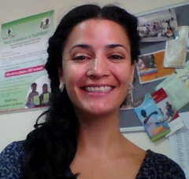

  - Maria Perdomo

Maria Perdomo has 10 years of experience in financial inclusion in 15 countries in Africa, Asia and Latin America. At UNCDF she manages YouthStart, a UNCDF Initiative that has brought financial services to more than 250,000 youth in sub-Saharan Africa. Prior to joining UNCDF, she worked for Reach Global, Freedom from Hunger and Microfinance Opportunities, where she developed Financial Education modules, trainings, capacity building tools and business models to enable different types of Financial Service Providers to offer integrated financial and non-financial services to their clients. She holds a Master’s Degree in International Affairs and Economic Development from Columbia University, and a Bachelor’s Degree from Externado de Colombia University and l’Institut de Sciences Politiques de Paris (Sciences-Po). She is a native Spanish speaker and is fluent in English and French.

