Questions & Answers for: RFA - Development of Ethiopia’s National Digital Payments Strategy – Phase 2

- Q. Is there possibility to extend the application deadline beyond 10 January 2020?
Ans: As the RFA indicates, the selected firm is expected to start on the 1st February or as soon as the contract
is signed by both parties. It is therefore not possible under the circumstances to extend the application
deadline beyond 10th January 2020

- Q. What are the selection criteria the Alliance will use in selecting the right firm for this assignment?
Ans: As per UN standards and given that this is a performance-based agreement, the assessment will be based
on the applicant’s Technical Proposal (100%)

- Q. What are the key components considered under the Technical Proposal?
Ans: As per the RFA, the selected firm will be assessed based their submitted approach and
Implementation plan, as described in Section 3, as indicated below:
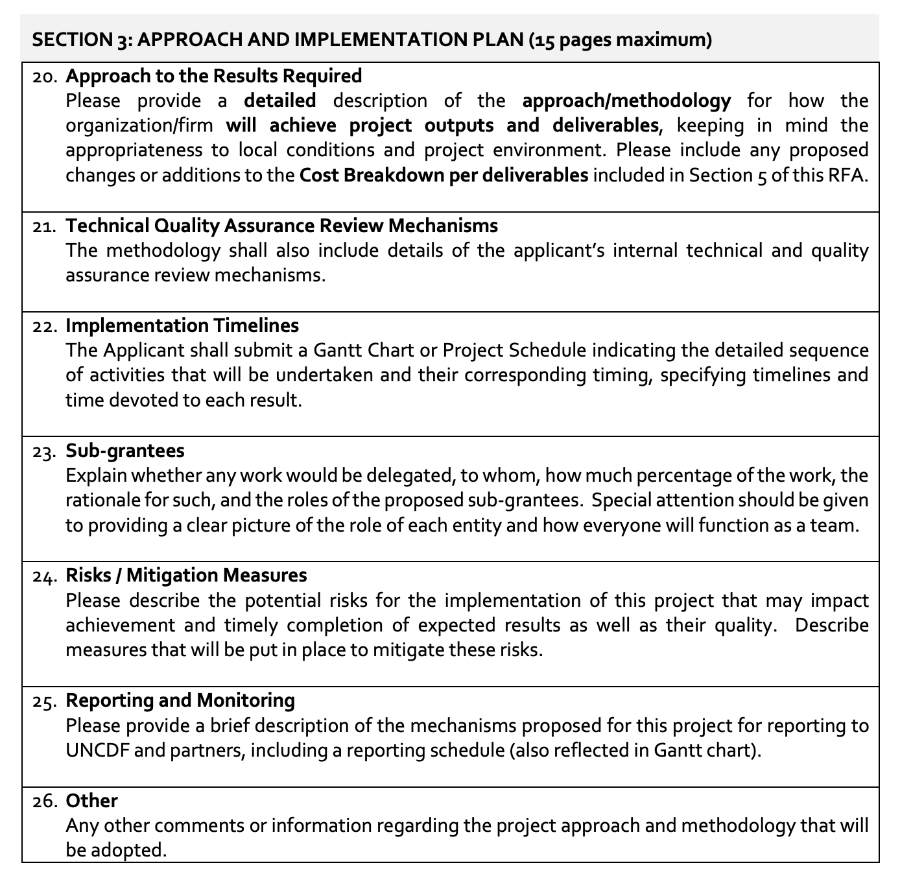

- Q. Will there be an opportunity to present the proposal to the Selection Committee and be available to
answer questions?
Ans: Given the timelines, it will not be possible for firms to present their proposals to the selection committee. Applicants are therefore advised to be as articulate and clear in their proposals as possible. The evaluation committee will base their decisions on the above criteria as submitted in the proposals.

- Q. What is the expected start date of the assignment?
Ans: the selected firm is expected to start on 1st of February 2020 or as soon as the contract is signed by both
parties.

- Q. Will the Alliance advise firms that may not have been selected for the assignment?
Ans. The Alliance will advise all applicants on the outcome of their application. Since this is a competitive
process, the Alliance is however not obliged to explain or provide reasons for non-selection to each firm.

- Q. What are the expected timelines for the assignment?
Ans: The National Digital Payment Strategy is expected to be finalised and handed over to the NBE by 31st March 2020. An implementation plan to the strategy is expected to be completed by 30 April 2020.

- Q. Could you provide a copy of the submission template in word to make it easy to submit the proposal?
Ans: There is no submission Template. Please use the RFA format, as advertised.

