Testing branchless banking to deliver cash transfers in Nepal

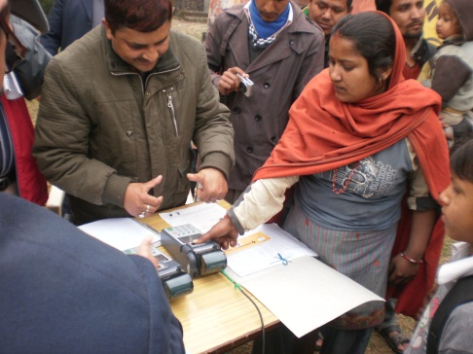
The Human Development Social Protection Pilot (HDSPP) is a sub-project of the joint UNDP-UNCDF Local Governance and Community Development Program (LGCDP).
It has been initiated in two far-western districts in Nepal, Kanchanpur and Dhadheldura and it is being implemented by the Ministry of Federal Affairs and Local Development (MOFALD).

The purpose of the HDSPP is to strengthen the capacity and role of central and local government in delivering social protection cash transfers through branchless banking and, within this context, to strengthen linkages between the education sector and local government accountability to citizens.

Why the focus on social protection in Nepal?

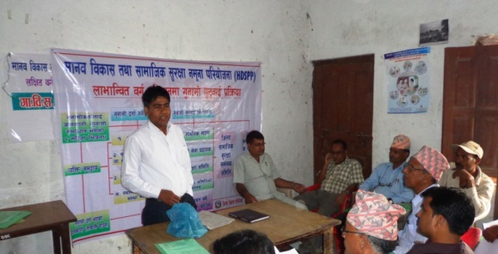
When compared to countries of similar wealth and development, Nepal is well-advanced in the provision of safety net programmes. The Government of Nepal runs various cash based safety nets programs for the protection of vulnerable groups. Some of the nationwide programmes in Nepal are categorical cash transfers to elderly, single women, disabled, endangered ethnicities and children administered by the MOFALD and categorical scholarships administered by the Ministry of Education (MOE). However, the total coverage of cash transfer programs is not sufficient. In addition, nearly all record keeping and cash transfers are done manually. In the case of MOFALD, Village Development Committee (VDC) Secretaries physically carry the cash from the District Development Committees (DDCs) and deliver it to the beneficiaries. In urban areas with relatively good coverage of banks, MOFALD has begun delivering cash through beneficiary bank accounts.
In the case of MOE scholarships, school management committees collect the cash from the district education offices and deliver it to students.

In the absence of a comprehensive electronic database of beneficiaries and an electronic payment system for benefits, these transfers are prone to leakages and to a high level of fiduciary risks.

Strengthening the efficiency of security payments

The HDSPP project on electronic cash is co-financed by UNCDF and the World Bank.

HDSPP tests poverty-targeted cash transfers and payments via branchless banking, facilitated by a robust management information system (MIS). One major component of the pilot is to improve the effectiveness and efficiency of cash transfer payments, changing from a manual to an electronic distribution of payments. Moving all the payments into a regularly updated electronic platform along with the usage of branchless banking services has the potential of improving service delivery as well as reducing overall fiduciary risks and leakage in the system, since payments are made directly into beneficiaries’ savings accounts.

Identifying the poor

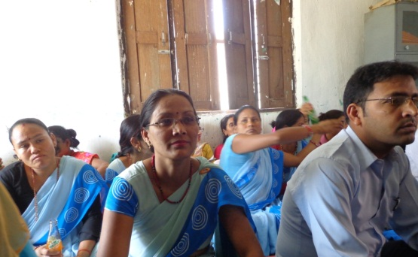
The current cash transfers in Nepal are mainly targeted to certain demographic categories and this significantly reduces their impact on poverty. The HDSPP focuses on poor children and pilots two different targeting methodologies for identifying the beneficiaries of the cash transfers: a Proxy Means Test (PMT) and a Multidimensional Poverty Index (MPI). PMT seeks to target households with the lowest per-capita consumption, while MPI targets households that are deprived in one or more of the three dimensions: education, standard of living, and social exclusion.
Preliminary analysis from the baseline survey of HDSPP suggests that communities find poverty targeting very useful.

The pilot project started with a household registration survey in all the 39 VDCs of the two selected districts. The household survey collected information on demographic and socio-economic characteristics: vital events registration (birth, death, marriage, divorce, migration); school attendance of children between the ages of 5 and 15; access to social protection programmes. The data from the household registration have been uploaded into a management information system (MIS) designed for MOFALD. Households have also been provided with a registration slip to track their vital events and citizenship-related documents stored in the MIS.

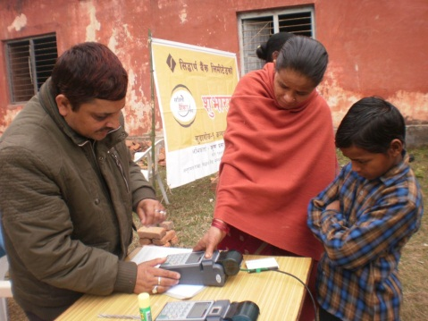
Based on the information collected, each household in the two pilot districts has been ranked according to their poverty score. Using this information, HDSPP aims to provide scholarships to approximately 26,000 children from the poorest households. To reduce overall inclusion and exclusion errors, the list of eligible beneficiary households was announced to communities at a public event, and households were provided the opportunity to file grievances through a newly established grievance mechanism, handled at the VDC level.

Delivering the cash via branchless banking

Each eligible child receives an annual grant of Rs. 1290 to be given in three tranches, for two academic years, conditioned on continued school enrollment. The scholarship is deposited into a bank account opened in the name of the child’s mother or guardian.

Through a competitive bidding process, Siddhartha Bank was selected as the pilot payment service provider. Each beneficiary child’s guardian is provided with a smart card and a savings account which will ensure overall access to formal financial services and offer future financial options for the beneficiaries.
Siddhartha Bank has selected and trained 31 payment agents across the two districts, ensuring that there is at least one agent in each VDC. These agents are local retailers – vendors with enough cash flow to maintain the flow of funds to beneficiaries. Beneficiaries can draw money from these agents by using a point of sale device, which scans their fingerprints and their cards, to verify their identity.

In addition to this, Siddhartha Bank accepted to provide services to non-beneficiaries who can make use of the expansion of the new agents’ network: interested customers are in this way able to open bank accounts and make use of the new agent network.

Initiating good practices

HDSPP is innovative in many ways:
-delivering government cash transfers via branchless banking in rural areas for the first time through a secured system.
-moving all the payments into a regularly updated electronic platform along with the usage of branchless banking services thus improving service delivery reducing overall fiduciary risks and leakage in the cash transfer system.
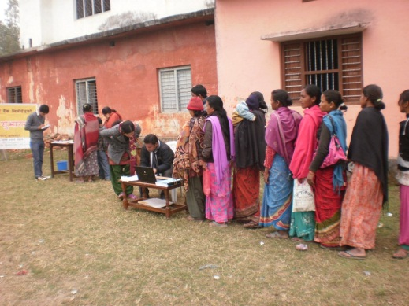
-strengthening financial inclusion offering new and improved access to appropriate, sustainable financial services in remote areas where they had not previously been available.
-establishing local grievance mechanisms.
-reinforcing horizontal coordination between local institutions; local bodies and the Department of Education.
-moving forward the debate on poverty targeting methodologies when allocating cash transfers.
-providing MOFALD with a platform to manage data on vital events and cash transfers and to monitor payments through the MIS.
-contributing, thanks to the lessons learned from the pilot, to strengthen the government’s existing cash transfer programmes.

Branchless banking is defined as the delivery of financial services outside conventional bank branches, often using agents and relying on information and communications technologies to transmit transaction details – typical examples include automated teller machines, card-reading point-of-sale (POS) terminals or mobile phones.

