First regular session 2018
22-26 January 2018, New York

Item 4 of the provisional agenda

United Nations Capital Development Framework

UNCDF Strategic Framework, 2018-2021

Summary

The present document outlines the UNCDF Strategic Framework, 2018-2021. It aims to support the achievement of sustainable development goals 1 and 17 in least developed countries by making finance work for inclusion, in collaboration with UNDP and other United Nations partners. UNCDF will do this by building on its years of experience in expanding inclusive financial markets and local development finance systems that help unlock public and private finance at the local level.
In building on its core competencies, UNCDF will pursue innovative finance solutions through: (a) financial inclusion that expands the opportunities for individuals, households, and small and medium-sized enterprises to participate in the local economy, with a focus on digital financial services; and (b) local development finance that shows how fiscal decentralization, municipal finance, and structured project finance can promote local economic expansion and local climate adaptation. Women’s economic empowerment is articulated across all UNCDF work.
The Strategic Framework articulates how UNCDF will strengthen its lending and guarantee instruments alongside its grants and technical assistance, and presents the role of the least developed countries investment platform in making blended finance approaches available to a wider range of United Nations partners, if called upon and funded to do so.
The Strategic Framework identifies four results-to-resources scenarios, providing Member States the means to recommit to supporting UNCDF to achieve the ideal scenario, which includes $25 million per year in core; $75 million per year in programme funding; and a $50 million capitalization of the LDC Investment Fund. This would support a strategic presence in 40 least developed countries.

The Executive Board may wish to take note of the Strategic Framework, 2018-2021.

Global context: opportunities and challenges
- The 2030 Agenda for Sustainable Development commits to leaving no one behind, and to meeting the goals and targets for all nations and all segments of society. The Addis Ababa Action Agenda and the 2030 Agenda identify the need for multiple sources of finance, public and private, domestic and international, to work together effectively and in new combinations. Yet only a small fraction of global investment assets is targeted at sectors and localities that advance sustainable development in developing countries. Investment flows that do go to least developed countries concentrate on too few countries and sectors and, within least developed countries, often flow towards extractive industries, real estate, or narrow infrastructure corridors. Between 2012 and 2015, only 7 per cent of private finance mobilized by official development finance through guarantees and other private sector instruments targeted least developed countries. Many stakeholders are wary of investing in local economies, given concerns over absorptive capacity, risk, low returns, and sustainability.
- The danger is that resources will continue to be allocated in ways that entrench exclusions and inequalities between and within countries rather than overcoming them. Important initiatives with the potential for transformational impact at the local economic level in least developed countries may continue to fall ‘below the radar’ of public and private investors.
- UNCDF uses official development assistance to make finance work for the inclusion of those who risk being left behind. UNCDF aims to increase and shift the dynamics of financing towards the local level, by providing the demonstration space for least developed countries to deploy innovative finance approaches that ‘crowd-in’ the additional public and private, domestic and international finance needed to accelerate progress towards the sustainable development goals.

Guiding principles of the Strategic Framework
- Making finance work for inclusion. UNCDF uses data, diagnostics, and analyses to identify ‘pain points’ and unmet needs where the lack of access to finance holds back development. It provides a mix of technical assistance and capital instruments to help its partners design and test innovations in response. Through its demonstration effect, UNCDF prepares the ground for public and private stakeholders to replicate and scale up viable models. UNCDF also supports policy and regulatory changes to ensure ecosystem change and wider market and systems development.
- Responding to needs of least developed countries. The Strategic Framework is grounded in the UNCDF mandate to support the least developed countries “first and foremost”, and a recognition of the unique challenges and opportunities these countries face. The Istanbul Programme of Action sets the target of enabling half of the least developed countries to meet the graduation criteria by 2020. UNCDF is committed to helping least developed countries meet their graduation goals through inclusive pathways, and to supporting smooth transition following graduation.
- Focusing on the ‘last mile’ and risk appetite. UNCDF is designed to have a risk tolerance to operate where few are focusing on the localities, men and women; small and medium-sized enterprises; and local governments that are underserved and excluded; where development needs are greatest; and where finance flows are most scarce.
- Aligning with global agendas. The Strategic Framework is aligned with the 2030 Agenda, primarily focusing on sustainable development goals 1, on poverty eradication, and 17, on the means of implementation. UNCDF contributes to other goals by identifying targets where local finance solutions can overcome entrenched obstacles to progress. The quadrennial comprehensive policy review emphasizes the importance of such integrated approaches. The Strategic Framework also responds to the Addis Ababa Action Agenda; the Paris Agreement on climate change; and the New Urban Agenda. It will retain the flexibility necessary to address decisions arising from follow-up to policy review-mandated processes, especially as they relate to questions on innovative financing.
- Building on strengths. This Strategic Framework optimizes UNCDF strengths and capital mandate. UNCDF will continue to pursue innovative finance solutions through:
(a) Financial inclusion that expands the opportunities for individuals, households, and small and medium-sized enterprises to participate in the local economy. UNCDF helps provide differentiated products for women and for men so they can move out of poverty, manage their financial lives, invest in their businesses and productive assets, and build a more resilient future for themselves and their families, making use of digital and other new technologies;
(b) Local development finance that shows how fiscal decentralization, innovative municipal finance, and structured project finance can drive public and private funding that underpins local economic expansion, women’s economic empowerment, climate adaptation, and sustainable development; and
(c) A least developed countries investment platform that provides the vehicle to expand deployment of capital instruments to a growing pipeline of projects in the last mile in least developed countries. UNCDF programmes in the above two areas provide the ‘feed’ and reduce the risk of investment opportunities, in order to ‘crowd-in’ follow-on domestic and international finance. The platform rests on the UNCDF enterprise risk management and loans and guarantees policies; strengthened due diligence processes for vetting and risk assessment of potential loans or guarantees; and dedicated and growing capacities to manage and oversee non-grant capital investments as a portfolio and ensure robust accountability. If the funding and demand are there, the platform could eventually be expanded to consider last-mile finance pipelines from UNDP and the wider United Nations development system across a range of sustainable development goals. The platform will rest on pursuing innovative resourcing models with a variety of public and private sector partners.
- ‘Learning by doing’ and innovation to scale. UNCDF will continue to base its interventions on sound evidence and lessons learned, and is committed to building a stronger evidence base around the longer-term impact of its work. UNCDF will emphasize collection and analysis of data and use of supply- and demand-side diagnostics, as these are revealing markets; driving innovations; and informing policies and systems development. UNCDF will continue to work extensively with digital accelerators based on evidence of efficiency gains, new market development, and gains in inclusion across a number of the goals. Through these approaches, UNCDF seeks to help least developed countries and other implementing partners to scale and replicate successes.

Lessons from the previous Strategic Framework
10. UNCDF has captured important lessons over the previous Strategic Framework from the midterm review; an external review of the UNCDF results-based measurement system, financed by UNDP’s Independent Evaluation Office; and an internal synthesis report of the findings of seven of the eight external evaluations completed since the start of the previous Strategic Framework.
- UNCDF was found to design and implement programmes that improve the lives of poor people and communities. It was judged to be good at designing interventions relevant to least developed country priorities, well-positioned with regard to other development stakeholders, and in line with the needs of implementing partners. Gender was particularly well addressed, with women’s financial inclusion and women’s engagement in local decision-making processes prioritized in programme design. Areas for improvement included the need to better articulate expected results beyond the level of direct implementing partners, and to ensure that oversight systems can better support the UNCDF ambition to influence the development of markets and systems that drive inclusion.
- The UNCDF inclusive finance partner organizations were found generally to be making good use of new financial products and services. Technological innovations, such as digital delivery channels, were helping them reach increased numbers of low-income clients, expanding, for example, their access to affordable clean energy or formal savings products. UNCDF support to improve public financial management by local governments typically yields increased investments in productive infrastructure as well as – where relevant – improved household food security and nutrition. While UNCDF is good at identifying the right implementing partners, it should do better in ensuring timely programme delivery and appropriate monitoring, results reporting, and knowledge management, particularly during the innovation stage.
- In terms of impact and sustainability, UNCDF interventions typically reach last-mile populations. UNCDF could more systematically take its innovations to scale, as most programmes lack fully articulated management and monitoring systems to drive this shift. To that end, UNCDF should engage more strategically with a wider range of policy and market actors throughout its programme cycle.
- UNCDF efforts on its results measurement system since 2014 were regarded as a “considerable achievement”. The integrated results and resources matrix was judged to be well aligned with the Strategic Framework and supported by a cost-effective system. Gender equality and women’s empowerment were found to be well embedded in the matrix following its update in 2016, though leaving room for improvement. Full integration of the matrix into results measurement at the programme level had yet to be achieved; the use of results data for external reporting and programme management could be improved; and aspects of the UNCDF mandate, such as services to the poor and protection of the environment, were not fully covered in previous results measurement systems.
- The results measurement review recommended simplifying the integrated results and resources matrix by reducing the number of expected results and performance indicators; and better representing the evolving work of UNCDF, notably in market system development and public-private partnerships. It recommended more visible links between expenditure and results, and increased attention to improving the quality of results reporting. Those recommendations are addressed in the matrix accompanying this Strategic Framework.

IV. Key elements of the Strategic Framework

- The logic of the Strategic Framework is captured in the schematic below.
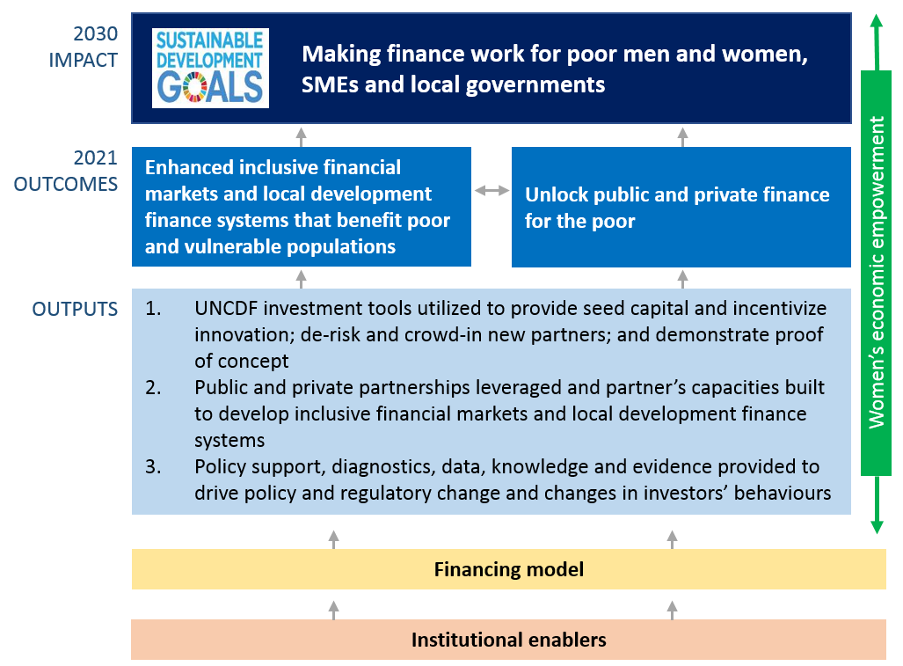
Note: SMEs = small and medium-sized enterprises
Envisaged impact
- UNCDF will work as an enabler, accelerator, facilitator, and convener, both to transform the way other actors invest and to help least developed countries create the right conditions to mobilize and channel a wider range of resources to the local level. Sustainable development goals 1 (especially targets 1.4, 1.5, 1.a. and 1.b), and 17, on the means of implementation (especially targets 17.1, 17.3 and 17.17), are embedded in all interventions.
- Women’s economic empowerment is specifically articulated across all UNCDF work in terms of objectives, approaches, theory of change, targets, and indicators.
- The envisaged impact will be achieved through two mutually supportive outcomes:
(a) Enhanced inclusive financial markets and local development finance systems that benefit poor and vulnerable populations; and
(b) ‘Unlocked’ public and private finance for the poor.
- UNCDF will target specific groups and geographies in least developed countries:
- Poor, underserved, and vulnerable populations experiencing sharp inequalities and exclusions in terms of access to finance, especially women and youth;
- Small and medium-sized enterprises and financial service providers in need of finance to grow and stimulate local economies; and
- Local governments in secondary cities, rural, and peri-urban areas.
Outcome 1. Enhanced inclusive financial markets and local development finance systems that benefit poor and vulnerable populations
- In local development finance, UNCDF focuses on innovating finance models that bring localities and excluded populations into the development mainstream. Spatially blind policy approaches have often failed to develop diversified rural and urban economies. Fiscal resources and domestic capital markets are not typically invested in local governments and local economies in ways that promote equitable growth. The benefits of growth therefore bypass many populations, and many catalytic infrastructure projects cannot get built.
- In supporting least developed countries to build inclusive, resilient economies, UNCDF adopts a transformative-impact financing approach to promote service delivery, infrastructure investment, and local economic development that retains value within a local territory. UNCDF seed capital and technical assistance will focus on helping localities build local fiscal space and local fixed capital formation. The chart below explains how complementary interventions build local development finance systems and markets:

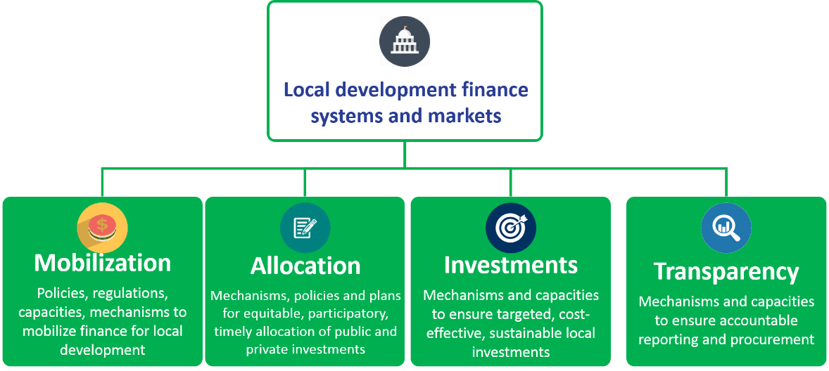

- Working with local governments, domestic banks, and local businesses, UNCDF provides evidence-based in-country analysis that informs the local development processes in the fields of fiscal decentralization, local public finance, and own resource revenues.
- To create the demonstration effects needed to support wider shifts in sustainable development goals financing, UNCDF helps least developed countries design and pilot financing mechanisms and business models that support locally designed public investments and revenue-generating capital investment projects. These are applied to addressing specific development bottlenecks.
- In helping to develop national systems for local government finance, UNCDF supports fiscal decentralization models and improved public expenditure management systems at the local level to get finance flowing to secondary cities, peri-urban localities, and rural areas. This includes work in crisis-affected settings, where UNCDF has a long track record of programmes that help local authorities rebuild trust between citizens and government. UNCDF deploys performance-based grants and technical assistance to strengthen the ability of local governments to plan, budget, invest, and report on investments, as well as to develop new funding mechanisms and investment-friendly policies and regulations.
- In line with sustainable development goals 11.1 and 11.3 to enhance inclusive and sustainable urbanization, UNCDF is working with municipalities in secondary cities to leverage funding through public-private partnerships, bonds, and own-source revenue. In rural areas, where most least developed country populations live, UNCDF will help municipalities develop finance mechanisms that improve food security and nutrition through investments in infrastructure and local food systems.
- In response to goal 5.4, UNCDF will help local governments strengthen their public finance management systems, planning, and budgeting processes so that more resources are allocated for initiatives that empower women.
- While local governments are on the front lines of response, most climate finance is centrally allocated and managed. Sustainable development goals targets 13.1, 13.2, 13.a, and 13.b call for increasing capacities and ensuring funding for effective climate change planning and action in least developed countries, including in local and marginalized communities. UNCDF will continue channelling performance-based, climate-resilient grants through intergovernmental fiscal transfer mechanisms. This develops systems that increase financing available to local governments, so that they can build verifiable climate-resilient infrastructure. The demonstration effect of this work helps governments access global climate finance – through the Green Climate Fund, for example – by gaining accreditation of the national implementing entity, which can access the climate finance directly and channel it through local government mechanisms. UNCDF will also develop verifiable mechanisms for attracting concessional finance to private and public-private investments that have a measurable climate-change impact.
- To support revenue-generating investments, UNCDF will help least developed countries design pilots that attract domestic resources into local economies on a more systematic basis, increasing local productivity and creating domestic markets for local economic development finance. Through structured project finance, small and medium-sized enterprise finance, and public-private partnership approaches, UNCDF will support public and private actors to de-risk, build, and unlock private financing for pipelines of investable projects with strong development impact. This will include, in conjunction with UNDP and UN-Women, public and private gender-sensitive infrastructure investments, as well as women-led projects. This work responds to sustainable development goal 9.a, which calls for supporting sustainable, resilient infrastructure development through increased financial and technical support.
- Between 2014 and 2016, UNCDF supported over 1,000 local governments in expanding their capacities for public local finance management. It facilitated cumulative investments in some 4,200 infrastructure projects, benefiting an estimated 9 million people. Under the ideal resource scenario (table 1, below), UNCDF would be able to support over 2,400 local governments. It could help build over 4,300 impactful local infrastructure projects annually, providing benefits to a projected 10 million people. By generating greater demonstration value, this supports catalytic leverage, as measured by outcome 2.
- At the policy level, UNCDF will continue to highlight the importance of local governments and local finance systems in responding to global challenges. It will contribute to relevant policy fora and strengthen relations with local government associations, networks, and financing agencies.
- Through its data and analysis, demonstration effects, and advocacy, UNCDF will support policy change that leads to improved local government financing systems and legislation. UNCDF will collaborate with public and private partners that can adapt, replicate, and scale what works.
- Financial inclusion contributes to broader development goals, and is reflected in targets under seven of the sustainable development goals. Less than 27 per cent of adults in least developed countries have bank accounts; women are more financially excluded than men; and the financing gap for micro, small and medium-sized enterprises is particularly wide. UNCDF concentrates on building inclusive financial systems that reach excluded and under-banked populations and small and medium-sized enterprises. Increasing access to financial services can help people move out of poverty, grow businesses, and reduce inequality.
- Through its market systems approach, UNCDF will work with financial service providers while creating enabling environments to reach underserved populations and market segments, especially women, youth, and micro, small and medium-sized enterprises.

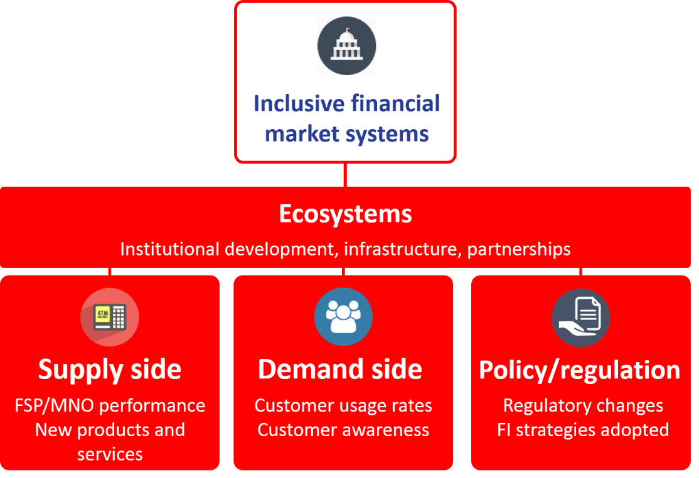
FSP = financial service provider; MNO = mobile network operator; FI = financial inclusion
- Central to building inclusive financial markets is helping least developed countries develop appropriate ecosystems, where policies, infrastructure, providers, distribution and client-centric approaches are strengthened in a mutually reinforcing way. By helping to build strong ecosystems, UNCDF is creating a foundation upon which innovative financial inclusion models can be tested and scaled up.
- Digital innovations have revolutionized the way financial services are provided and used, and have created new business models to expand access to basic goods and services. Leveraging this digital revolution, UNCDF will seek to address a growing range of ‘real economy’ challenges linked to the sustainable development goals, such as improving agriculture productivity for smallholder farmers and value chain actors, enabling access to clean energy and other basic services, or supporting micro-, small and medium-sized enterprise growth, including in such sectors such as the ‘fintech’ industry. These interventions will especially target women and youth.
- UNCDF has developed data-driven diagnostics that reveal markets and trends, and empower governments to define financial inclusion strategies tailored to their circumstances and needs. These tools create strong national platforms for donor coordination and private sector engagement. UNCDF will continue to deploy such approaches, building capacities and reinforcing coordination among stakeholders, especially regulators and financial service providers.
- On the supply side, UNCDF will use its capital tools and technical assistance to incentivize financial services providers to design and deliver client-centric product innovations using alternative delivery channels – such as rural agents, mobile phones, point-of-sales devices, and informal community groups – to reach underserved populations, especially women, youth, and smallholder farmers.
- UNCDF places a strong emphasis on savings, as well as insurance, credit, domestic payments and remittances. It is increasingly working with new actors, such as ‘fintech’, mobile network operators, and new technologies, especially digital financial services. This is in line with sustainable development goals targets on financial inclusion, including 8.3, 8.6, 8.10, and 9.3 on expanding access to financial services for households and small and medium-sized enterprises, and integrating the latter into value chains.
- UNCDF will support small and medium-sized enterprises, including social enterprises that have business ideas with potentially high social returns and market impact, but are struggling to raise early-stage capital. A prime example is UNCDF work with energy service companies to expand access to efficient cook-stoves and solar home systems through ‘pay-as-you-go’ models. Such approaches address high up-front retail costs that prevent poor people from accessing off-grid alternatives, responding to targets 7.1 and 7.b on increasing access to affordable energy services.
- Remittances are a growing part of the sustainable development goals financing equation and UNCDF work. Their importance is captured under goal 17.3 and its indicator (volume of remittances as a proportion of total gross domestic product) and goal 10.c (which calls for reducing the transaction costs of migrant remittances). UNCDF will work with governments and service providers to formalize remittance channels leveraging digital and fintech solutions to lower costs and link remittances to a wider range of financial services for senders and recipients.
- Based on its successful experience with digital payments in the Ebola crisis, UNCDF will expand its work on financial inclusion in fragile and post-crisis contexts, focusing on refugees and forcibly displaced people through its partnership with the Office of the United Nations High Commissioner for Refugees. UNCDF will help least developed countries make preparedness investments in digital infrastructure, strengthen their capacity to deploy emergency payment solutions, and build longer-term resilience solutions for affected populations.
- On the demand side, UNCDF assists financial service providers in using human-centred design to understand the needs of women, men, and youth, and develop appropriate products and services. When combined with building client capabilities and client protection, this approach leads to greater usage and more benefit to clients. UNCDF will expand its work on client capabilities and protection, focusing increasingly on digital finance deployments.
- Between 2014 and 2016, UNCDF partnered with over 130 institutions and supported the innovation of 98 financial products and services. The financial service providers reached some 14 million clients in 2016 alone. Under the ideal resource scenario, UNCDF has the potential to partner with some 320 financial service providers, with diversified financial products reaching up to 35 million clients annually.
- UNCDF seeks to make financial market systems work for women by expanding the supply of responsible financial products that respond to the specific needs of women and girls; supporting policies and regulations that enhance women’s access and agency in regard to financial services; and addressing constraints that limit women’s and girls’ access to, usage of, and control over benefits from financial services, particularly in ways that contribute to their greater economic empowerment and participation. This is a direct response to sustainable development goals targets 1.4, 5.a and 5.b.
- UNCDF hosts the secretariat of the Better Than Cash Alliance. This reflects its strong stake in one of the critical issues driving financial inclusion: transitioning from cash to electronic payments. Continued advocacy by the Alliance, including on responsible digital payment guidelines, is advancing global recognition of how digitizing payments can benefit individuals, businesses, and governments. The Alliance supports its member governments, private sector actors, and development organizations in achieving the sustainable development goals by moving from cash to digital payments. UNCDF will continue to support the Secretary-General’s Special Advocate for Inclusive Finance for Development, H.M Queen Máxima of the Netherlands, whose work remains instrumental in raising, at the highest levels of decision-making, the importance of financial inclusion as a vehicle to improve lives and development outcomes.
Outcome 2. Unlocked public and private finance for the poor
- Unlocking public and private finance for inclusion is at the heart of the UNCDF comparative advantage as an early stage ‘de-risker’, helping least developed countries leverage official development assistance for wider sustainable development goals financing. This relates particularly to goals 1.a, 10.b, and 17.3, on mobilizing additional financial resources from multiple sources, especially for least developed countries.
- In line with goal 17.1, UNCDF will work to strengthen domestic resource mobilization, which reduces dependency on often-volatile external flows, helps build economic resilience, and gives least developed countries greater policy space to define their goals and the means to attain them. The ‘unlocking’ work of UNCDF covers both financial and catalytic leverage.
- Financial leverage refers to the complementary finance mobilized for the innovations directly supported by UNCDF. On local development finance, through its work on public finance, UNCDF seeks to increase resource transfers to local governments while helping them increase own-revenue generation. Through its private finance work, UNCDF seeks to increase the amount of domestic finance invested outside capital cities, and to help local governments leverage and manage different sources of capital to build prioritized projects, many of which have long remained unfunded.
- To demonstrate to investors the economic viability of funding local projects with transformative impact, UNCDF will continue working with local governments and the private sector to de-risk and build bankable projects. In some cases, this may result in the successful financial closure of projects with investments from domestic banks or pension funds. In others, UNCDF will explore new mixes of guarantees, concessional loans, and technical assistance to create the financial leverage. This can include deploying financial instruments such as municipal bonds or retail investment bonds that can attract diaspora funding for local infrastructure.
- Access to formal financial services increases financial intermediation by putting domestic resources into productive circulation. Financial inclusion supports household resilience, enabling greater engagement in income- and employment-generating activities for women in particular. UNCDF seed capital in a financial service provider is leveraged by its own equity or that of other investors to expand and scale up its services.
- UNCDF interventions have follow-on and scaled-up impact through their catalytic leverage. This refers to additional finance mobilized by local actors as a result of the models and capacities originally supported by UNCDF. UNCDF interventions spur the creation of national systems and platforms that can attract investors and unlock additional finance on an ongoing basis. This is connected with UNCDF work in moving from innovation to scale.
- A mix of factors contributes to successfully scaling up UNCDF-supported models: a willingness to take risks and pivot approaches as the market evolves; the ability to learn dynamically and respond to lessons; a recognition by UNCDF and its funding and implementing partners that shifting behaviours and financing flows require patience and often extends beyond single planning cycles; and decades-long partnerships with a range of public and private actors through which UNCDF is able to leverage its results to inform national policies and programmes that can scale successes.
- In local development finance, UNCDF will continue to collaborate with governments and other partners, often through multiple generations of innovations, first to create viable models and then to help them scale approaches to fiscal decentralization, project finance, and municipal finance. This can lead to increased local revenue through taxes and fees – as well as second-round effects through growing local economies – as can UNCDF work building the capacities of local authorities to improve the accountability of their tax administration.
- As an example, UNCDF invested $10 million in core funding to pilot and test local development finance approaches in Bangladesh over 15 years. What began in 2000, in one of the 64 districts, was eventually scaled up across the country by the World Bank with $720 million and government funds. In 2016, a donor government provided an additional $400 million to continue expanding the nationwide scale-up. Similar leverage occurs in most local development finance programmes.
- UNCDF support to financial service providers and other partners seeks a demonstration impact that will help other service providers to replicate successful innovations. By creating safe spaces for piloting smart products and delivery channels – such as the innovation labs in Uganda and the Pacific – UNCDF helps unlock the balance sheets of large commercial actors to reach the un-and under-banked with new services.
- For example, a regional programme in Africa focused on youth financial inclusion. It led to 730,000 young people saving some $20 million, with $16 million in loans being issued to 125,000 young entrepreneurs, over half of them women. Nine out of 10 partner financial service providers made youth products an ongoing feature in their offering, reaching new clients and mobilizing additional savings.
- Expanding financial inclusion can support overall economic growth, create more stable financial systems and economies, and boost government revenue and fiscal space. Moving from cash to digital payments can reduce costs, improve transparency, expand financial inclusion, and open up new economic opportunities. Mobile money has significant poverty reduction benefits, especially for female-headed households.
- Catalytic leverage typically evolves beyond the annual or project-life measurement cycle. To capture it, UNCDF will deploy more thematic and impact evaluations and conduct case studies that take a wider view of an intervention and how it attracts follow-on finance over time.
- Supporting countries to engage in South-South and triangular cooperation around local finance solutions will be emphasized across both outcomes by:
(a) Helping regional groups (such as the Association of Southeast Asian Nations, the Southern African Development Community, the West African Economic and Monetary Union, and the Pacific Small Island Developing States) expand the reach of financial inclusion, including through multi-country approaches to remittances, data and analytics, refugees;
(b) Facilitating knowledge exchanges on issues including reaching out to un- and under-banked populations; applying digital finance solutions; and moving from cash to electronic payments; and
(c) Bringing policymakers, experts, local authorities, and the private sector together to shift resource allocation dynamics in favour of subnational levels for action on, for instance, local climate adaptation; municipal finance; and local infrastructure.
- Crossing the least developed country graduation threshold may not in itself change the living conditions for millions of people, and will require smooth transition support. Five countries where UNCDF has a presence are in various stages of the graduation process: Bhutan; Nepal; the Solomon Islands; Tuvalu; and Vanuatu. Other countries might meet the graduation criteria for the first time in 2018; if their progress is sustained, graduation would be as early as 2024.
- The UNCDF approach will be based on demand; will assure that relevant existing programmes can proceed through to completion; and will be time-bound, to follow a ‘3+2’ approach. This would see programmes funded as they were prior to graduation for an initial three years. Assuming continued development progress, funding for the remaining two years of support would be sought from government or third-party cost-sharing on a 50/50 basis.

V. Partnerships and financing model

- UNCDF has a four-window funding architecture to drive its innovation-to-scale approach and make maximum use of its technical assistance and block grants, loans, and guarantees.
- As window one, core resources are the bedrock of the UNCDF business model, providing the technical expertise and flexible risk capital to innovate, pilot, and start achieving leverage. A core resource base that is right-sized and fit for purpose is the essential fuel UNCDF needs to maintain its recognized positioning within its peer networks, assure country presence in the maximum number of least developed countries, and stay at the forefront of last-mile finance innovations.
- Funding windows two (Last-Mile Finance Trust Fund) and three (earmarked non-core) assure UNCDF the non-core resources to build robust, scalable programmes at country and multi-country levels, building on the core and creating meaningful scale to achieve demonstration effect across different country and local settings; influence policy and regulatory environments; and ‘crowd-in’ other interested partners.
- To help least developed countries benefit from the application of innovative finance instruments at the local level, funding window four – the LDC Investment Fund – provides the additional investment capital for UNCDF to build investible pipelines, reduce the risks of investment opportunities, and demonstrate business model viability across a larger number of initiatives. UNCDF has already identified around 60 catalytic projects to feed into this investment pipeline over the next two years. Under an ideal resource scenario, with a fully capitalized LDC Investment Fund, UNCDF could support up to 400 investable projects over the next four years. UNCDF risk capital could ‘crowd-in’ up to 20 times additional funding for an individual investment.
- With predictable funding in these four areas, UNCDF can also be a more catalytic and strategic partner to governments, UNDP (including in support to its country platform approach), and the wider United Nations development system in testing innovative finance approaches. The strategic and ideal scenarios can help drive this more robust positioning. The baseline scenario, by contrast, allows presence in fewer least developed countries and restricts strategic engagement in some countries where UNCDF has limited project funding.
- UNCDF aims to build a loan portfolio that can attract more public and private investors into the ‘last mile’ in least developed countries. Funds generated from loan repayments would be on-lent to new borrowers, supporting a bigger pipeline of bankable initiatives compared to one-off grants.
- Different results-to-resources scenarios project anticipated annual results under pessimistic, baseline, strategic, and ideal scenarios. Under the ideal scenario, UNCDF would have annually $25 million core, $75 million in non-core, and a $50 million LDC Investment Fund.
- Under that scenario, UNCDF can be present in up to 40 least developed countries. If called upon by the United Nations system and funded to do so, UNCDF will be available to support United Nations efforts to apply blended finance approaches across the sustainable development goals at the local level.
Table 1. Indicative income and results-to-resources scenarios
Scenarios | Pessimistic  (-20%) | Baseline | Strategic | Ideal
Resource projections
Total | $ 46m | $ 58m | $ 95m | $ 150m
Core | $ 11m | $ 13m | $ 19m | $ 25m
Non-core | $ 35m | $ 45m | $ 66m | $ 75m
LDC Investment Fund |  |  | $ 10m | $ 50m
Indicative implications of different resources levels on people and partners reached (sample programme annual results projections)
Strategic least developed country (LDC) presence | <15 LDCs | Currently 30 LDCs, but 8-9 LDCs at risk | 30 LDCs | 40 LDCs
People reached* | 5 million | 16 million | 27 million | 45 million
Partnerships | Support  20 financial service providers (FSPs) and 570 local governments (LGs) | Support  134 FSPs and 854 LGs | Support  200 FSPs, 1,740 LGs, and 20 investment pipeline projects | Support  320 FSPs, 2,415 LGs, and up to 100 investment pipeline projects
* Based on number of financial service clients from UNCDF-supported financial service providers and estimated beneficiaries from UNCDF-supported local infrastructure investments.
- Achieving expanded UNCDF results would be cost efficient: the relatively fixed costs of corporate infrastructure, such as capital assets and human resources, would support a higher level of activity without proportional increases in overhead costs.
- Working with United Nations and multilateral partners. UNCDF will work with other United Nations entities to introduce more integrated approaches to making finance work for inclusion.
- Collaboration with UNDP. The synergies between UNDP and UNCDF are designed to bring maximum benefit to least developed countries. UNCDF local finance solutions and subnational focus are a natural counterpart to the UNDP global presence, upstream policy advice, and support for the sustainable development goals at the country level. Both entities share the overarching objective of eradicating poverty and reducing inequalities and exclusions. At the programmatic level, UNCDF has nearly 20 joint programmes with UNDP, which comprised well over a quarter of its 2016 expenditure. UNDP provides a range of operational and administrative support services to UNCDF in the areas of finance, procurement, human resource management, and information technology, including through its enterprise resource planning system. The UNDP Strategic Plan, 2018-2021, presents a strong platform for closer collaboration between the two organizations.
- Within the United Nations development system. UNCDF collaborates with other entities where the combination of its capital tools and expertise and the sector or thematic knowledge of other organizations can help tackle last-mile exclusions and have transformative impact. Partnerships include:
(a) UNDP and UN-Women, on unlocking capital for women’s economic empowerment and entrepreneurship;
(b) UNDP to expand financial inclusion in the Pacific;
(c) The Food and Agriculture Organization, on agriculture finance;
(d) The International Fund for Agricultural Development, on remittances;
(e) UN-Habitat and the Department of Economic and Social Affairs, on municipal finance in secondary cities in least developed countries;
(f) UN-Women, on women and girls’ access to, usage of, and control of benefits from financial services; and
(g) The Office of the United Nations High Commissioner for Refugees, on a technical assistance fund for introducing digital financial solutions that benefit forcibly displaced populations and host communities.
- At the programme country level, UNCDF will engage in United Nations Development Assistance Framework processes, country-level results groups, and joint programmes and initiatives, as financing for country presence allows. UNCDF will continue to engage in inter-agency processes at headquarters and regional levels.
- As more organizations look to support innovative financing solutions, UNCDF can play a key role as incubator for new financing models and ideas, and support the rest of the United Nations system to replicate what works. This could include identifying opportunities for attracting financing from capital markets for development initiatives, and working with public and private investors to direct sustainable development goal-friendly asset classes towards the ‘last mile’ in least developed countries. It could also include building on UNCDF collaboration with UNDP and other organizations to understand where entrenched barriers exist across a wider range of development issues and sustainable development goals, and innovating tailored finance solutions. This could include work in the peacebuilding space, and/or addressing populations on the move.
- UNCDF and the Better Than Cash Alliance have developed first-rate advocacy, research, and technical expertise on digitizing payments. Both are successfully helping governments transition towards sustainable digital economies and reap the benefits of digitization, including cost savings, increased transparency, and better service delivery mechanisms to beneficiaries. To build an inclusive digital payments ecosystem, UNCDF works with the private sector to improve the technology, distribution, and product design to reach low income people. A growing number of United Nations organizations are joining the Better Than Cash Alliance and committing to digitized payments; where appropriate, UNCDF and the Alliance can apply their expertise to help United Nations organizations drive costs down, increase efficiencies, and support achievement of the sustainable development goals through the transition to digital finance services.
- International finance institutions and other financial institutions. UNCDF combines the attributes of a development organization and a financial institution, using a calibrated, risk-informed mix of instruments to develop finance solutions that address last-mile needs in least developed countries. UNCDF is present at the sub-sovereign level, which is typically ‘below the radar’ of international financial institutions, either because of the risk profile or size of project. This provides ground for collaboration, already well tested with the World Bank, to take proven models (such as fiscal decentralization) to scale.
- UNCDF will continue to engage with these partners to maximize replication and scale potential, including collaborating with regional banks on market development in financial inclusion and ecosystems for digital payments. UNCDF will seek to partner strategically with international financial institutions in deploying financial instruments in ways that harness the respective collaborative advantages of each entity in support of least developed countries.
- Harnessing the power of the private sector and foundations. UNCDF will continue to work with a wide range of private sector actors as innovators, implementing partners, and possibly funders. This includes investing and partnering with financial service providers; mobile network operators; domestic banks; pension funds; small and medium-sized enterprises; foundations; and impact and other investors to expand the reach of finance in local economies.
- At the same time, UNCDF is working with least developed countries to access more finance for local development. This may include partnering with impact investment firms to create vehicles for directing sustainable development goal-positive finance to least developed countries; incentivizing domestic banks and pension funds to invest in local economies; and attracting financing from family offices and foundations to co-invest in UNCDF development and pipeline projects. It may also include organizing platforms that explore the sequencing of official development assistance, concessional, and commercial capital in the ‘last mile’, including UNCDF risk capital, Member State grant financing, seed funding from foundations, and return-seeking capital from impact, and philanthropic investors. To enhance last-mile development results in least developed countries, UNCDF may also seek to leverage its own resources by managing other investors’ funds in line with their objectives of achieving financial and social returns.
- Gender-responsive budgeting and programming. UNCDF has a theory of change that charts results pathways to promoting gender equality and women’s economic empowerment (see annex 3). This will help track commitments to empower women and improve the targeting of interventions. Programme results frameworks will continue to include sex-disaggregated indicators, and UNCDF will continue implementing and reporting on the System-wide Action Plan on Gender Equality and the Empowerment of Women.

VI. Operational effectiveness and efficiency

- UNCDF strives to be an adaptive organization, identifying continuous business change requirements, informed by performance data, and delivering high-quality programmes and value for money. The Strategic Framework identifies three enablers to ensure that UNCDF has the systems, staff, and tools to deliver excellent, relevant, and credible results.
- Management. UNCDF will continue to invest the majority of its resources in least developed countries. So that programmes deliver high-quality results, UNCDF continuously refines its management services to be client-focused, providing efficient support in procurement, finance, and human resources while supporting robust programme design and delivery against approved budgets. The integrated results and resources matrix (annex 1) includes a management-efficiency ratio which looks at the percentage of total UNCDF expenditure related to management activities; for 2016, the figure stood at 10 per cent, down from 14 per cent in 2014.
- In line with the results-based measurement review findings, UNCDF will make better use of its programme finance data to inform programme decision-making and grants management, and strengthen its data and information systems.
- Essential to ensuring that its interventions are replicable, UNCDF promotes accountability for results at all levels. This includes ensuring timely implementation of internal and external audit recommendations, and actions agreed in management responses to evaluations; and greater attention to risk management in line with the updated enterprise risk management policy. UNCDF will continue to meet International Aid Transparency Initiative standards, and will more frequently make data on results and resources publicly available.
- The integrated results and resources matrix has been strengthened to allow better monitoring of results and results-to-resources linkages. UNCDF will strengthen its results-based management and budgeting systems and capacities at all levels to improve performance. This will include further developing institutional systems to link the matrix with project results frameworks and facilitate integrated monitoring and reporting. In line with evaluation findings, UNCDF will continue to ensure that programmes have the right knowledge and partnership strategies in place to strengthen national ownership, and drive a sustainable shift from innovation to scale.
- UNCDF will focus on enhancing the capacities of key systems at the country level, including information management and accountability systems, to provide more timely, better-quality information to decision makers. UNCDF works with local governments to help them apply the subnational public expenditure and financial accountability framework in accordance with the global standard and use it to improve their investment decisions. UNCDF will ensure that financial inclusion implementing partners use industry-accepted standards; this will support stakeholders in accessing relevant data on their performance.
- UNCDF is developing country-based value propositions that offer integrated interventions, drawing on all relevant tools, to maximize support for least developed country priorities within overall United Nations responses.
- People. A talented, engaged staff, with deep finance knowledge and expertise on how to design excellent programmes and implement blended approaches in least developed countries, remains the greatest asset of UNCDF. Fully-funded programmes are magnets for recruiting high-quality staff – as are competitive terms of service, since much UNCDF talent comes from the private sector.
- UNCDF will continue to ensure that staff are equipped to deliver on goals; foster a culture of continuous learning; and strengthen skills for strategic engagement with new partners, including foundations, development banks, and the private sector. The aim is to create an environment that allows everyone to contribute to their full potential.
- UNCDF will strengthen its skills base related to applying diversified financing instruments and in areas where local finance solutions can remove barriers to sustainable development goals achievement. This includes such areas as remittances, youth employment through financial inclusion, and municipal finance.
- In line with the quadrennial comprehensive policy review, UNCDF will continue working to achieve gender and geographic balance in appointments at all levels.
- Knowledge, thought leadership, communications, and advocacy. Strengthening its position as a knowledge leader and advocate for last-mile finance is instrumental to the UNCDF approach. In line with findings from the results-based measurement review and evaluations, this will require continued investment in knowledge codification and sharing, and information management, including within peer networks, where UNCDF is a recognized leader in its fields of competence.
- UNCDF will collaborate with local authorities’ networks to support peer-to-peer exchanges and enhance their voice in global forums. It will work with financial inclusion funders and actors to share lessons and ensure that UNCDF practices respond to evidence and remain top-of-class as the field evolves. Investing in knowledge management is important in ensuring that pilots inform policy, replication, and scale potential.
- UNCDF will invest in a more robust thought leadership role. This will include developing flagship publications and convening partners to create momentum around blended finance approaches in least developed countries.
- UNCDF will continue to invest in external communications and advocacy through events, publications, and new web-based, digital, and social media tools, including its revamped website.

VII. Risk management
- There are several risks and opportunities surrounding the roll-out of the Strategic Framework. These relate to the mobilization of required resources and the related UNCDF country footprint; and the potential for further fragmentation of funding streams and capital instruments within the wider United Nations development system.
- The behaviour transformations required to get the right mix of international and domestic, public and private capital instruments lined up to make finance work for inclusion at the local level can take time. Impact will be gradual and may not always be successful at the first attempt.
- The institutional enablers and partnership strategies are designed to mitigate some of these risks through their emphasis on flexibility and agility in systems; human resources; programme management and monitoring; performance-based funding; and management arrangements. A ‘deal’ on programme resources and partnerships will be essential to mitigate unpredictability in the funding base, as official development assistance and grant funding remain essential to the successful deployment of blended finance models in the ‘last mile’ of least developed countries.
- In diversifying its financing tools and applying them, UNCDF faces risks related to right-sizing our capacities to identify pipelines best suited to blended finance models, and generating sufficient deal flow. UNCDF is ensuring that it has fit-for-purpose policies; stringent risk management, accountability, and oversight frameworks; a growing pool of specialist expertise to source and manage an investable pipeline; information and communications technology systems; robust due-diligence processes; and other necessary back-office functions. A detailed discussion of the risks and mitigating strategies is described in the theory of change (annex 2).

VIII. Monitoring and evaluation

- The results framework outlines the impact-, outcome-, and output-level indicators of the Strategic Framework. Baselines, annual milestones, and end-of-cycle targets for outcome and output indicators will track UNCDF contributions.
- There will be an emphasis on rigorous monitoring and evaluation to capture, share, and improve how UNCDF goes from innovation to scale, and on how it makes finance work for women and girls in particular, looking, inter alia, at issues around access, usage, agency, and participation. UNCDF will work with partners on impact and thematic evaluation approaches that consider the long-term effects of access to finance on the lives and livelihoods of women and, more broadly, the development of the communities in which they live. The annual report of the Executive Board will be the vehicle for reporting on progress towards the Strategic Framework targets. The midterm review will provide opportunities for reflection and adjustment, including in response to the outcomes of the quadrennial comprehensive policy review follow-up processes.
- In line with its commitments under the UNDP evaluation policy, UNCDF will continue to conduct external independent evaluations of programmes and projects. Achieving the ideal core resource targets could contribute to an increase in the evaluation capacity and coverage of the programme. The UNCDF evaluation unit and the UNDP Independent Evaluation Office will continue to collaborate on evaluation quality and approaches. Discussions are under way with the Independent Evaluation Office to provide for an independent final evaluation of the present Strategic Framework. A four-year evaluation plan, the first two years of which are costed, comprises annex 4.

UNCDF is an autonomous organization associated with UNDP. The UNDP Administrator is the Managing Director of UNCDF.
Includes goals 5, 7, 8, 9, 10, 11 and 13. UNCDF work can also contribute to wider goal 16-related responses in countries affected by conflict or natural disasters.
https://www.betterthancash.org/tools-research/reports/accelerators-to-an-inclusive-digital-payments-ecosystem
As part of its work overseeing the quality of evaluation in UNCDF, in accordance with the UNDP evaluation policy, the Independent Evaluation Office conducted an external quality assessment of these evaluations, assigning three scores of ‘5’ (satisfactory) and two scores of ‘6’ (highly satisfactory) to the five submitted by July 2017.
The UNCDF definition is broadly in line with the market systems approach to financial inclusion proposed by the Consultative Group to Assist the Poor. A market systems approach to financial inclusion: Guidelines for funders. Washington DC: CGAP, (2015).
See, for example, Financial Inclusion: Can It Meet Multiple Macroeconomic Goals? IMF discussion note, September 2015.
A study found that the Mexican Government is saving an estimated $1.27 billion per year by shifting to electronic distribution for many government payrolls, pensions and social benefits. Sustained Effort, Saving Billions: Lessons from the Mexican Government’s Shift to Electronic Payments, Better Than Cash Alliance, November 2013.
Mobile money has lifted some 2 per cent of the Kenyan population out of poverty, and has improved the economic lives of poor women and members of female-headed households. The long-run poverty and gender impacts of mobile money. Science, December 2016.
General Assembly resolution 67/221 on smooth transitions “[i]nvites United Nations entities that have committed to allocating a certain percentage of their resources to least developed countries to consider the extension and gradual phasing-out of least developed country-specific support to graduated countries for a fixed period of time in a predictable manner and applied according to the specific development situation of each graduating country.”

