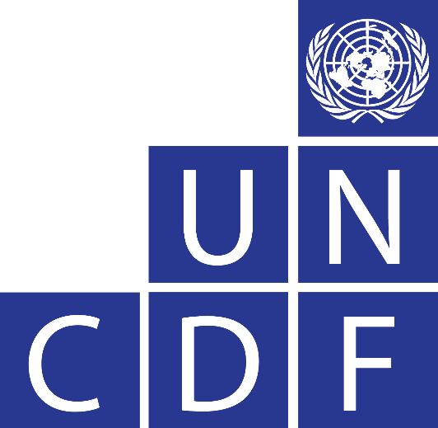

Ethiopia

Financial Services Access and Agency of

Women and Girls

Ethiopia Country Assessment Workshop

November 13, 2017

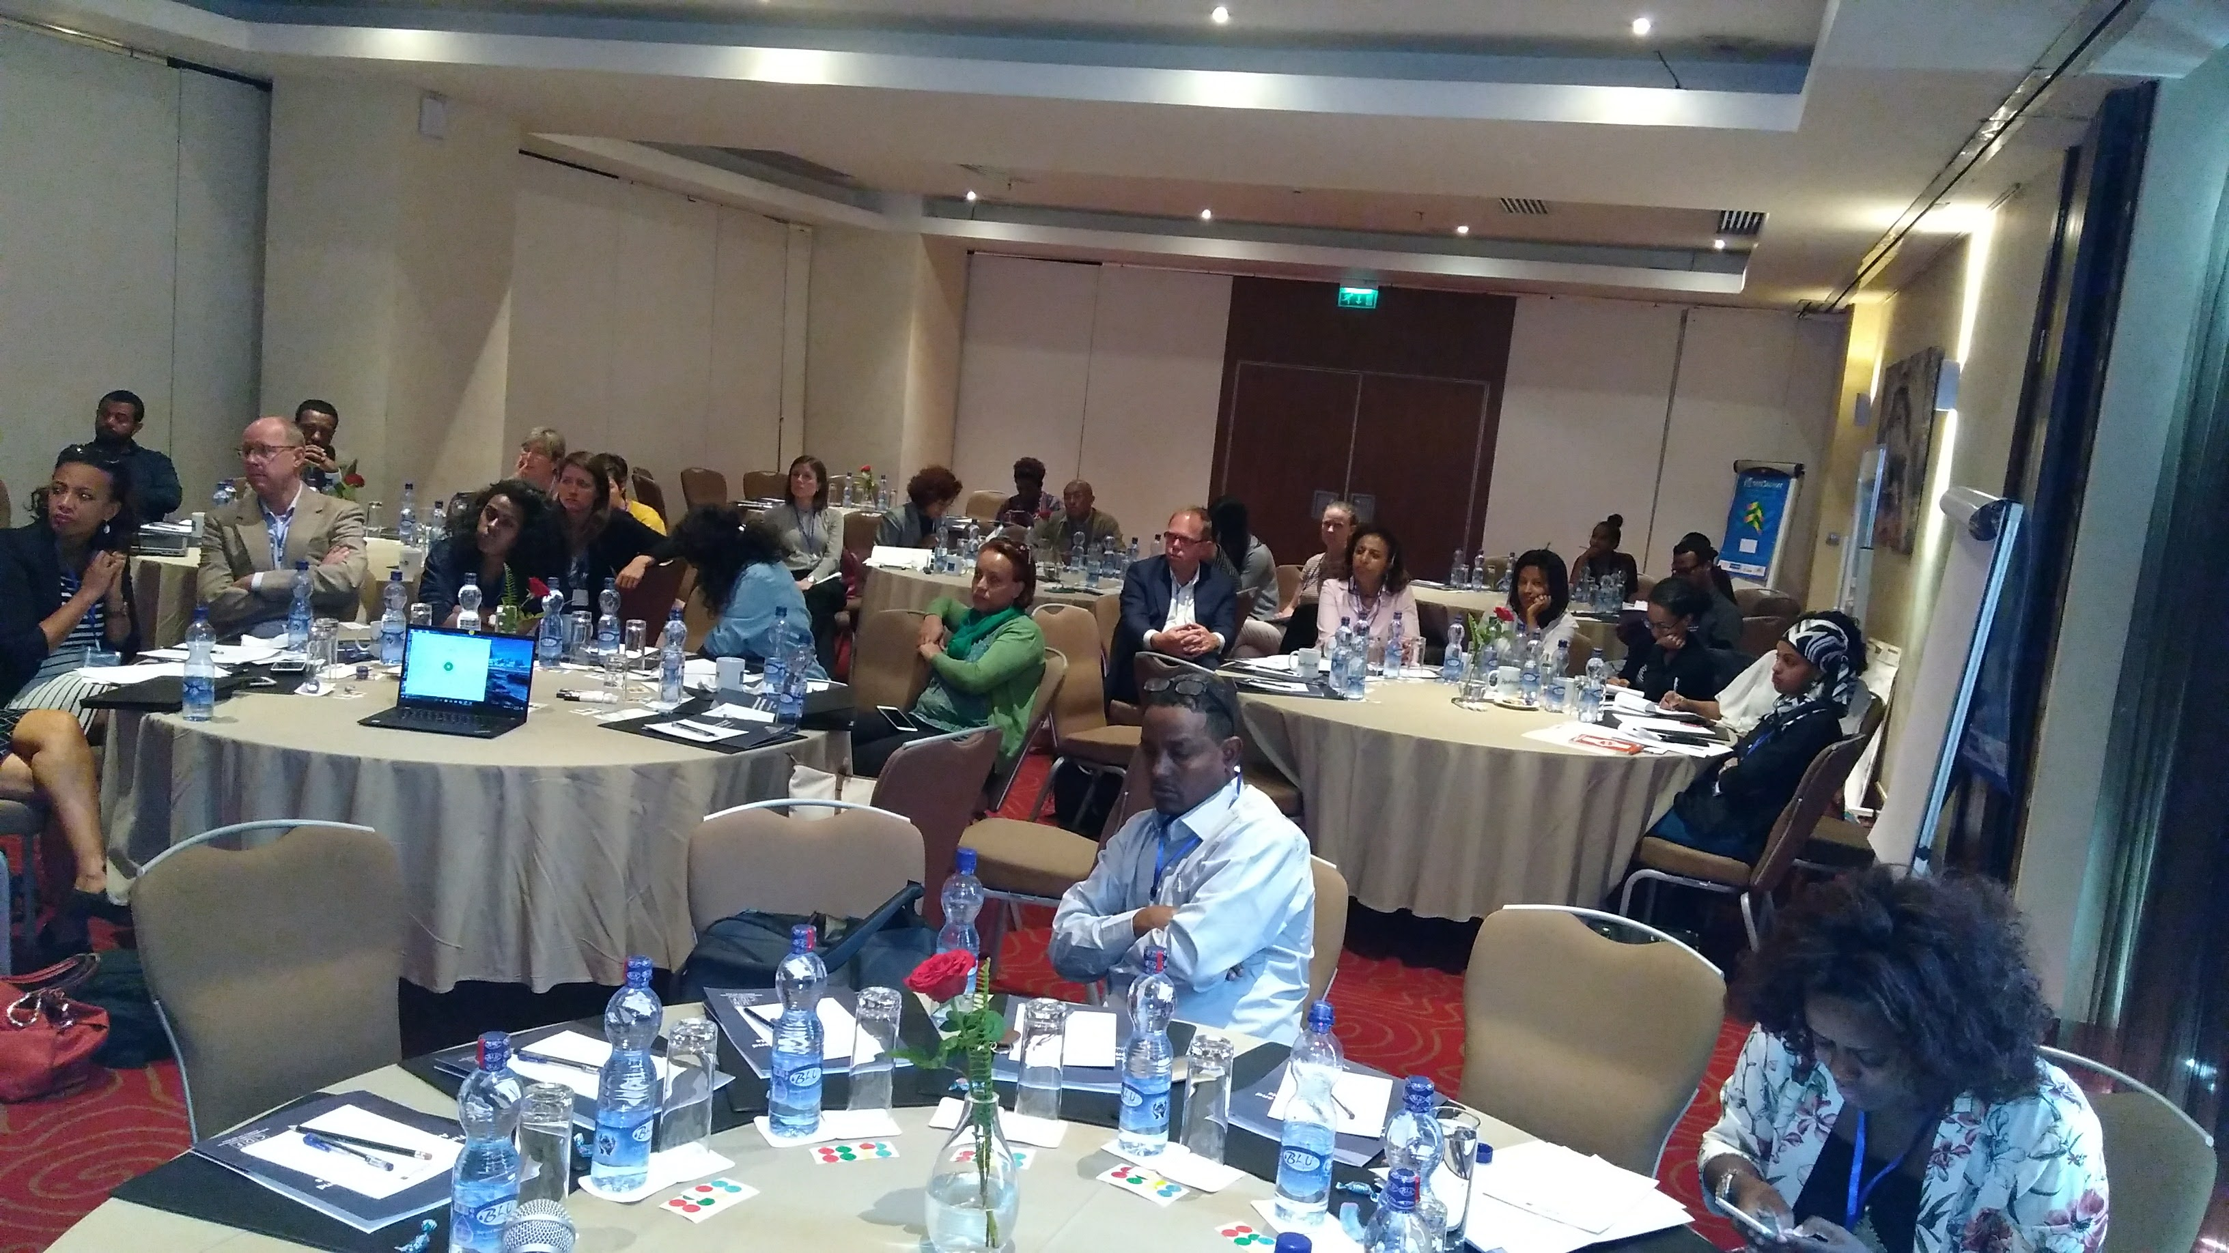

Background
Recognizing the essential role that financial inclusion plays in women and girls’ economic empowerment, UNCDF developed a global strategy, called “Participation of Women in the Economy Realized” (PoWER). Drawing on this framework, UNCDF developed a country assessment toolkit to assess the constraints faced by women and girls in different country contexts in accessing, using and controlling the benefits from financial services in ways that facilitate their greater economic empowerment. This work was undertaken with the assistance of Dalberg Global Development Advisors and supported by a planning grant from the Bill & Melinda Gates Foundation and with additional financial support from SIDA. This strategy will be operationalized at a country level with a market-led outlook to innovate, scale, and replicate evidence-based financial service interventions coupled with critical non-financial services that address these constraints. PoWER will help bridge existing gaps and reduce the barriers that impede women and girls’ access of, use of, and control of benefits from financial services.

The PoWER strategy is centered on a framework that identifies three key spheres of influence affecting women and girls’ financial inclusion: supply of financial services, demand for financial services, and the enabling policy and regulatory environment. These are mediated by socio-cultural context, or gender norms. To further understand the constraints and enablers in each of these spheres, UNCDF developed a toolkit to support the PoWER strategy. The toolkit has been deployed in multiple country assessments to gain a deeper understanding of the country-specific constraints that women and girls face. Ethiopia was one of five countries—along with Bangladesh, Ethiopia Senegal, and Tanzania—where the new UNCDF toolkit to assess the country context was piloted.

UNDF organized a workshop on 13th of November at Radisson Blue Hotel, Addis Ababa, Ethiopia, to share and validate Ethiopia’s country assessment findings and insights on key constraints and enablers of women and girls’ access, usage and control of finance across supply, demand and the enabling environment, and the cross-cutting socio-cultural context. Over 30 participants from government, private sector, development organizations, and funders attended the workshop. (See list of participants in Annex 2). Participants were invited to provide their perspectives on the insights and recommendations in the Ethiopian context. Based on the results of the Ethiopia country assessment and with the additional inputs from workshop participants and supplementary consultations with relevant external stakeholders and potential partners, an implementation plan for Ethiopia is being developed that includes convening, research, advocacy, capacity building and innovation funding to address the priority constraints and build on the enablers to enhance women’s economic empowerment in Ethiopia.

Opening remarks
Dr. Eyob Tesfaye, UNCDF Ethiopia Program Director, Financial Inclusion, made a welcome speech and gave an overview of the workshop. In the opening address, Dr. Tesfaye presented challenges facing women in financial inclusion in general, and in Ethiopia in particular. He provided a brief overview of the situation of women in the formal financial system, the strategies being used by the government of Ethiopia to unleash the potential of women and girls in economic development, and noted several initiatives from financial institutions to promote women’s financial inclusion in Ethiopia. Dr. Tesfaye encouraged those present at the workshop to participate actively and contribute ideas and suggestions during the workshop in order to validate the findings, help prioritize the key actions to be taken based on the assessment, and identify potential partnerships to advance the agenda.

Ms. Beth Porter, Financial Inclusion Policy Advisor at UNCDF, introduced the global PoWER strategic goals of 2018-2022. She noted that financial inclusion is achieved when all individuals and businesses have access to, and can effectively use, a broad range of quality, adapted financial services that are provided responsibly, and at reasonable cost, by sustainable institutions in a well-regulated environment. She noted the importance of identifying, understanding and addressing the key constraints and enablers faced by women and girls that affect their access to, usage of and control over financial services. She noted that there are three areas in which interventions can be made to the benefit of women and girls in this regard, that is: i) demand; ii) supply; and iii) the enabling environment. Cutting across all three spheres is the socio-cultural context and gendered norms that must be taken into consideration. Interventions across these three spheres will contribute to expanding the financial inclusion of women and girls that ultimately drives their economic empowerment and participation. And while financial inclusion is a critical driver of women’s economic empowerment—and the one that UNCDF is best placed to address—there are other drivers, such as education, delayed marriage, family planning, alleviation of unpaid care, work opportunities, property and assets, etc. that need to be addressed if women’s economic empowerment is to be achieved.

Key to UNCDF’s global PoWER strategy is the concept that women and girls transition through various life cycle stages that have a differential impact on them than their male counterparts. Moreover, as women and girls, they have distinct economic roles. Both of these factors mean that they have different financial constraints and needs, and therefore require specific products and services in the context of a gender-sensitive enabling legal, policy and regulatory environment, and that addresses women’s capabilities, voice and demand for finance, and control of benefits of financial service use.

Presentation of Country Assessment Findings
Ms. Herma Gebru, Senior Consultant at Dalberg Global Development Advisors, presented the Ethiopia Country Assessment findings. In the Financial Inclusion Portrait of Ethiopia, she noted that the gender financial gap stands at 9%, driven by the gap in bank use. Financial inclusion is growing in Ethiopia, but remains low compared to other countries in Sub-Saharan Africa. She stressed that Ethiopia still remains primarily an agriculture driven economy, with 65% of women engaging in agricultural activities, compared to 3% of women entering into formal employment. In general, the use of financial services is low across different segments of women and girls, with a variety of explanatory factors that are in part based on their lifecycle stages and in part by their economic roles.

Financial challenges of women were examined in relation to their different lifecycle stages. In Ethiopia, women were found to face particular financial challenges raising children, securing employment, migration, and early marriage where their financial need substantially increases. In Ethiopia, the key stages identified were: 1) primary to secondary school; 2) (Early) Marriage; 3) Childbirth; 4) Raising children and 5) Spousal death.

The country assessment also examined the women’s market according to five different economic roles: In-school girls; Out-of-School Girls; Employees; SME entrepreneurs; and Smallholder Farmers. Adaptive financial services are needed to ensure that the needs of women and girls in their different economic roles as well as at their different stages in their lifecycle are addressed. Currently women primarily relay on informal coping mechanisms to meet their needs. These remain inadequate to cover the range of their financial needs, however, and as they are informal, are subject to greater risks than financial services offered by regulated providers.

Mobility and time constraints, compounded by the limited number of access points, are key barriers that prevent women in Ethiopia from being able to access the financial sector. One such constraint can be found in the location of banks and bank branches: on average, an individual must walk 5-15km to access a bank. This distance is more pronounced in rural areas. Additionally, women’s mobility is restricted due to 1) the pressure on their time, and 2) social norms mandating that they seek permission from their spouse to leave the home. Women work over 16 hours a day, most of their time is spent on household duties including, family and child care, as well as market activities. Additionally, financial knowledge among women is below 30% for all metrics and almost 50% of women (especially the ones in rural areas) prefer to use informal savings methods.

Mobile money could address time and mobility constraints, but it is still relatively new. While there has been a dramatic increase in mobile phone penetration in Ethiopia over the past 7 years, the rate is substantially lower than elsewhere (for example, 39-point difference between Bangladesh and Ethiopia). 53% of rural women do not own mobile phone, primarily because of costs associated with owning phones. Additionally, among those who have a phone, 80% of surveyed respondents were not aware of mobile money accounts. This is likely associated with the relative newness of mobile money. Currently only three institutions are offering the service, but it has been rapidly growing in terms of the number of customers reached.

In terms of requirements, collateral was highlighted as one of the biggest constraints affecting women. Unlike other neighbouring countries, KYC requirements are less of a hurdle facing women. The National Bank of Ethiopia (NBE), has mandated that individuals are required to present some form of government issued photo ID in order to use financial services. In practice, banks are less likely to enforce this requirement. However, in the instance where it is enforced, migrant women are especially vulnerable given that may migrants are not registered, partially due to the challenges with obtaining a release document from their place of origin. When it comes to collateral, banks require up to 200% in collateral, typically in the form of fixed-assets, such as property. Women are less likely to own property, with a 15%-point gender gap in sole ownership of property which can be used as collateral.

In terms of use of financial products, all women who save, do so informally, with about 14% of savers using formal methods. The vast majority of women, at 76%, save for consumption and emergencies. On the other hand, borrowing is rare, only 14% of surveyed women borrowed in the last 12 months. About 40% of surveyed women cited that they did not believe in borrowing and 26% did not want to borrow. Focus group participants expressed fear for large-scale borrowing from financial institutions given the perceived risk associated with paying back. Other barriers to formal borrowing include lack of awareness of the services available and lack of products which are flexible enough to meet their needs, especially to smooth consumption.

Regarding issues of agency, the assessment found that beyond product usage, <50% of surveyed women report sole control of loans; 6% take large purchase decisions. The surveyed women feel that they control their savings, loans and insurance, but substantial number (32% of women) acknowledge that the husbands often have a bigger say in large household decisions.

Discussion Session
Participants raised a number of questions and comments following the presentation of the country assessment. Among the highlighted points from participants were:
- The need of understanding the difference in demand of financial services in urban and rural areas.
- The burden of women in the agrarian rural community needs to be considered by the financial service providers. For example, there are cases whereby the woman takes the loan in her name, but her male partner controls how the loan is used, leaving all the risk on the woman without allowing her control.
- The appropriateness of SACCOs versus other financial services in the rural areas and the need for them to distinguish their services for men and women was stressed.
- The pros of using banks is stated given that they provide better customer protection.
- To help alleviate the problem with lack of access of points in rural areas, government needs to be help increase SACCOs and MFIs with regulation and accessibility.
- There is a potential for mobile money and it helps to increase financial inclusion through partnership.
- The figures about mobile money usage in the assessment will be different soon as there is aggressive penetration of mobile providers which will change the landscape.
- A participant noted that in many areas, people do indeed trust their local SACCOs, although this varies by SACCOs, some of which are better organized and more trusted than others.

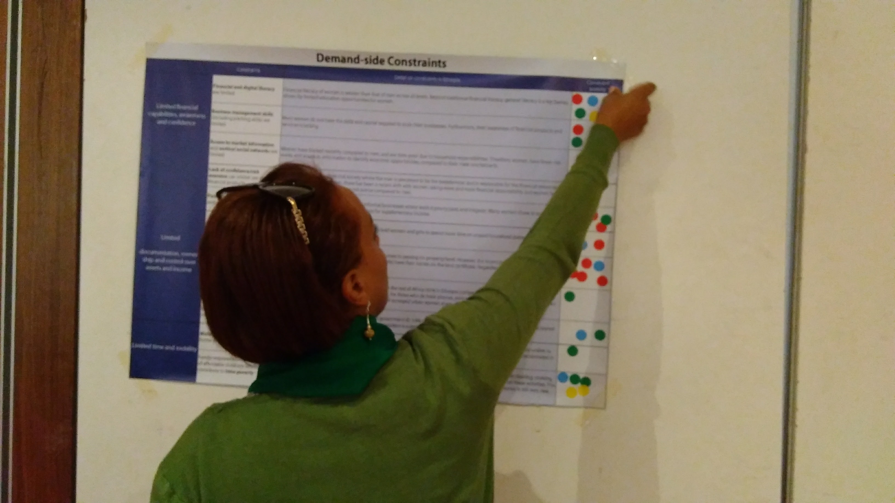
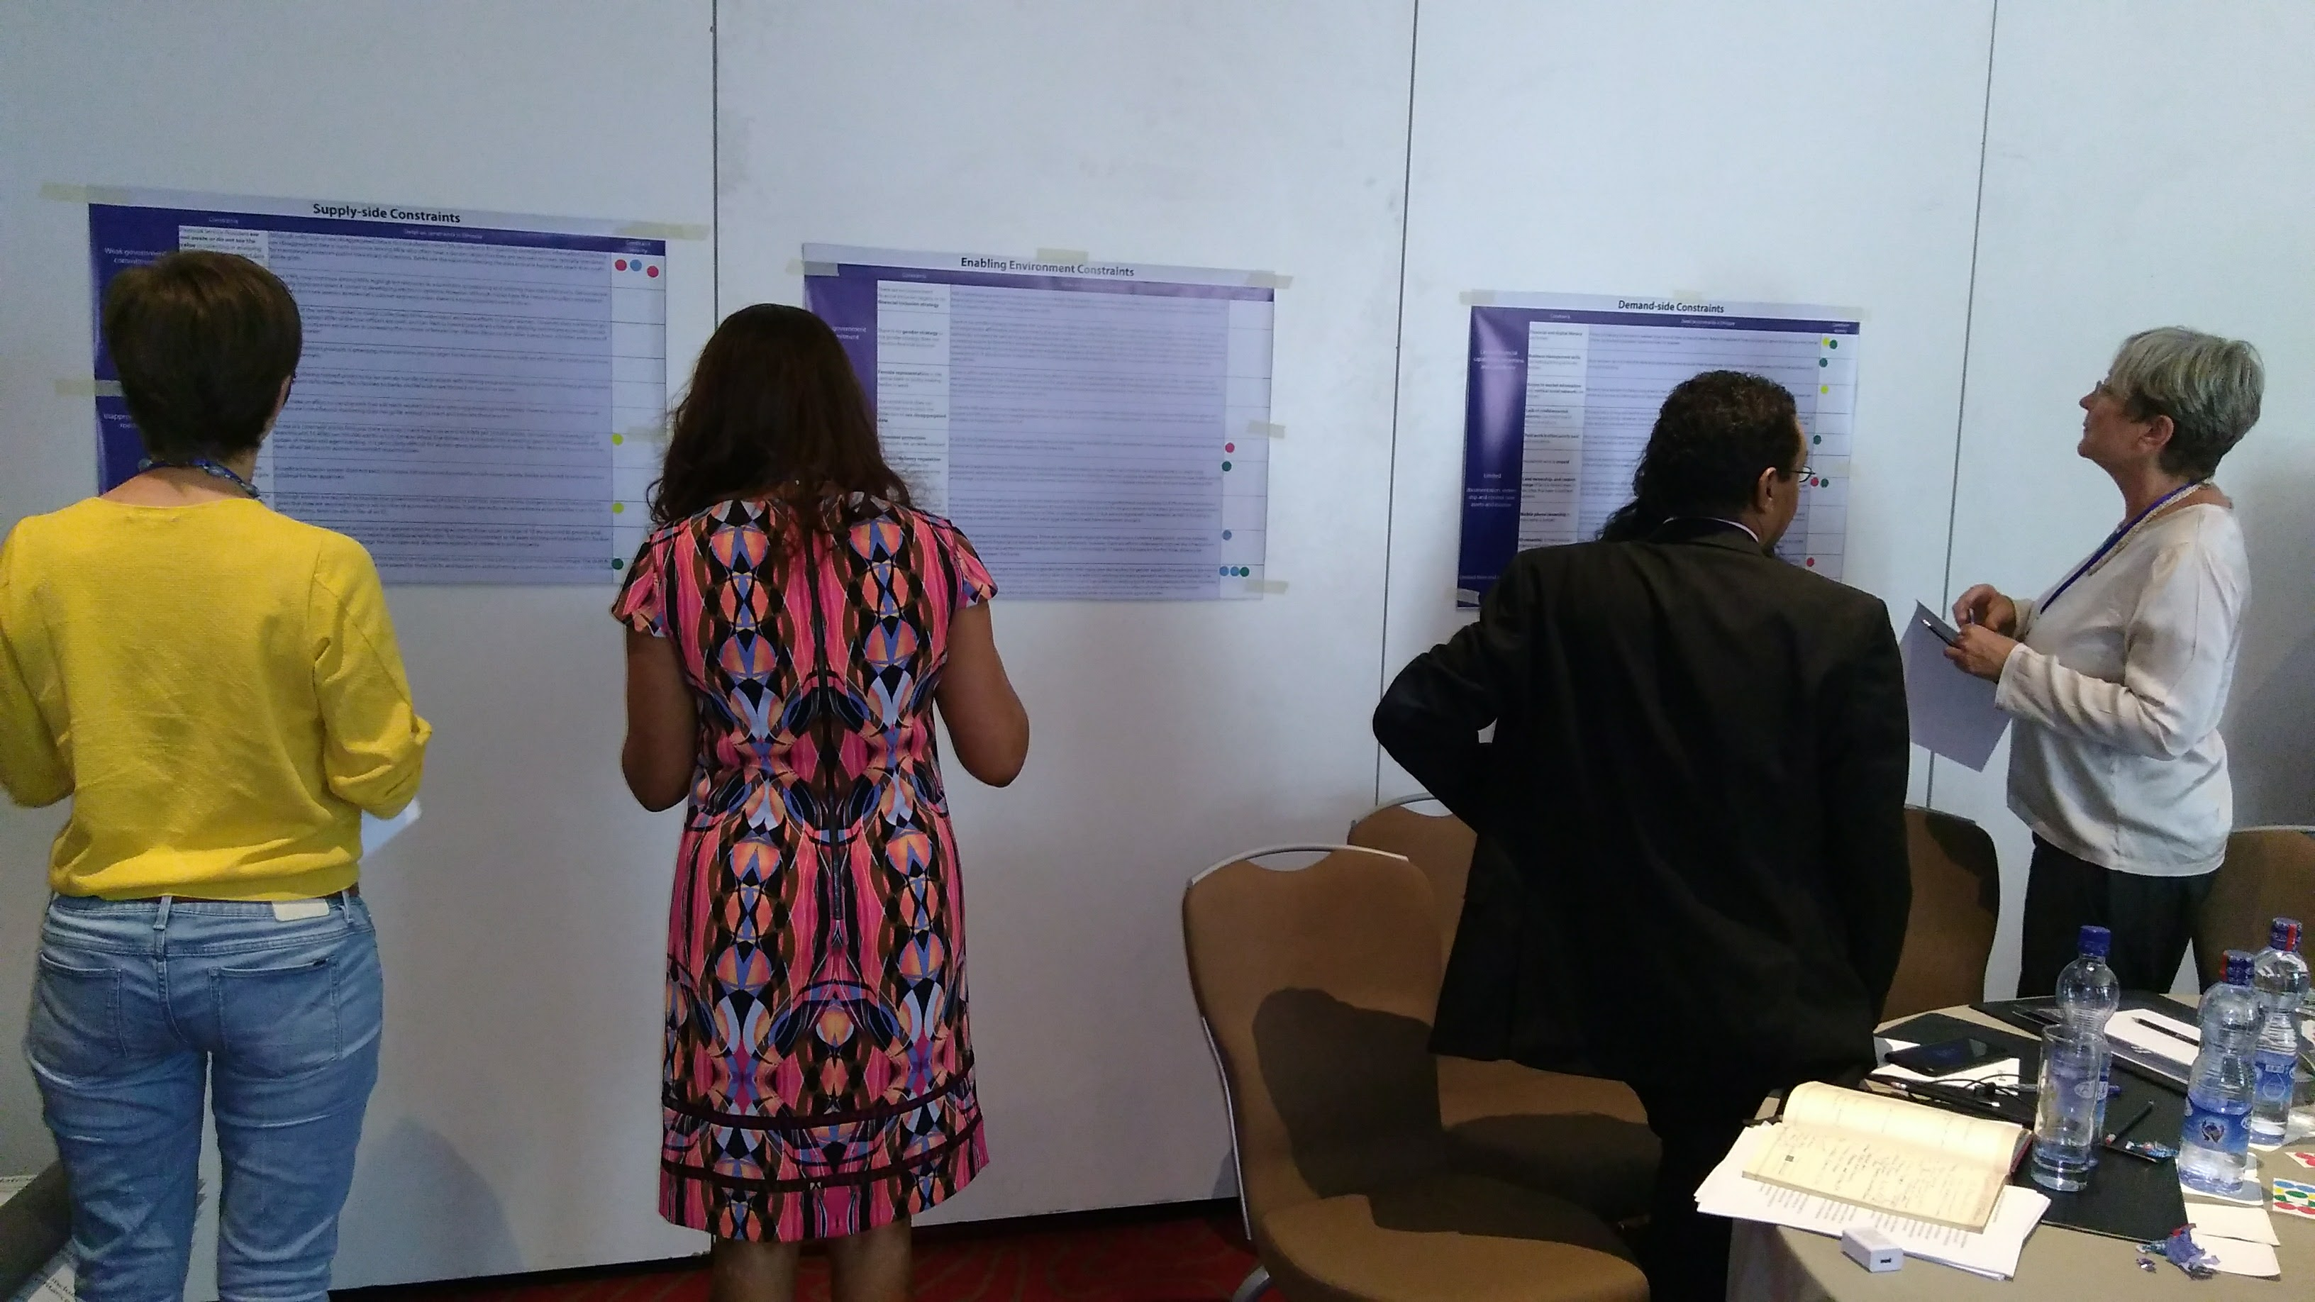

Interactive Activity #1: Prioritisation of Constraints
In order to prioritize the importance of the constraints identified in the country assessment report, workshop participants were given nine stickers (‘votes’) and asked to identify the three top constraints to women’s financial access that they thought were most severe across the three spheres of enabling environment, supply, and demand. The most severe constraints for each sphere are presented in the following chart.

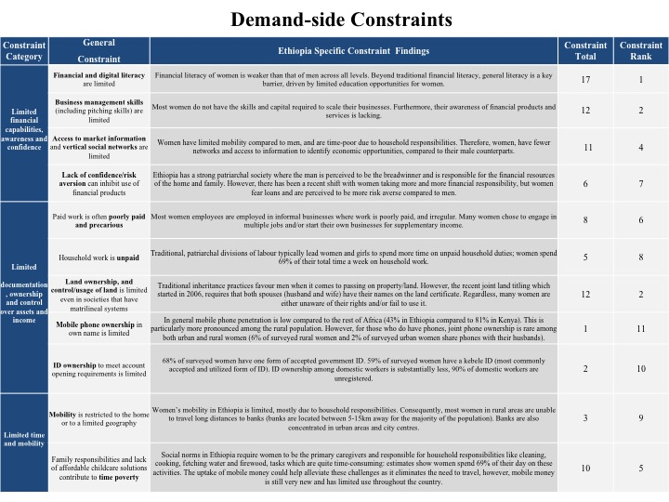
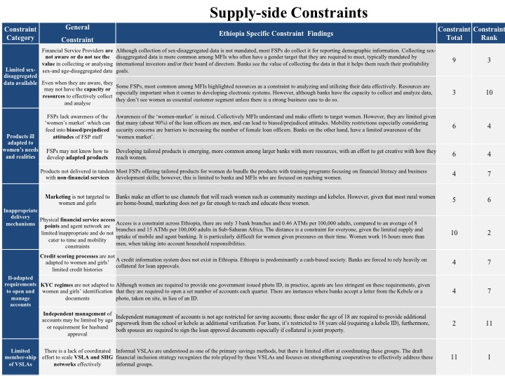

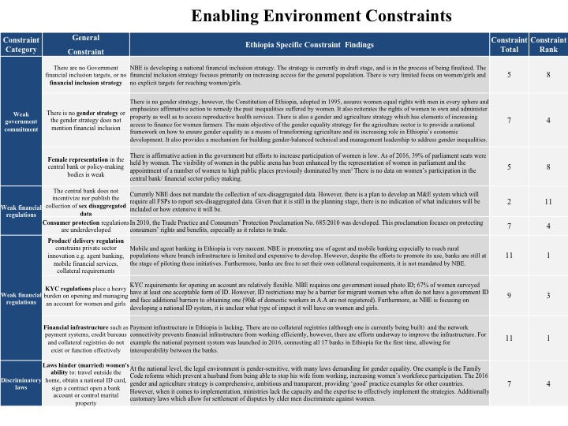

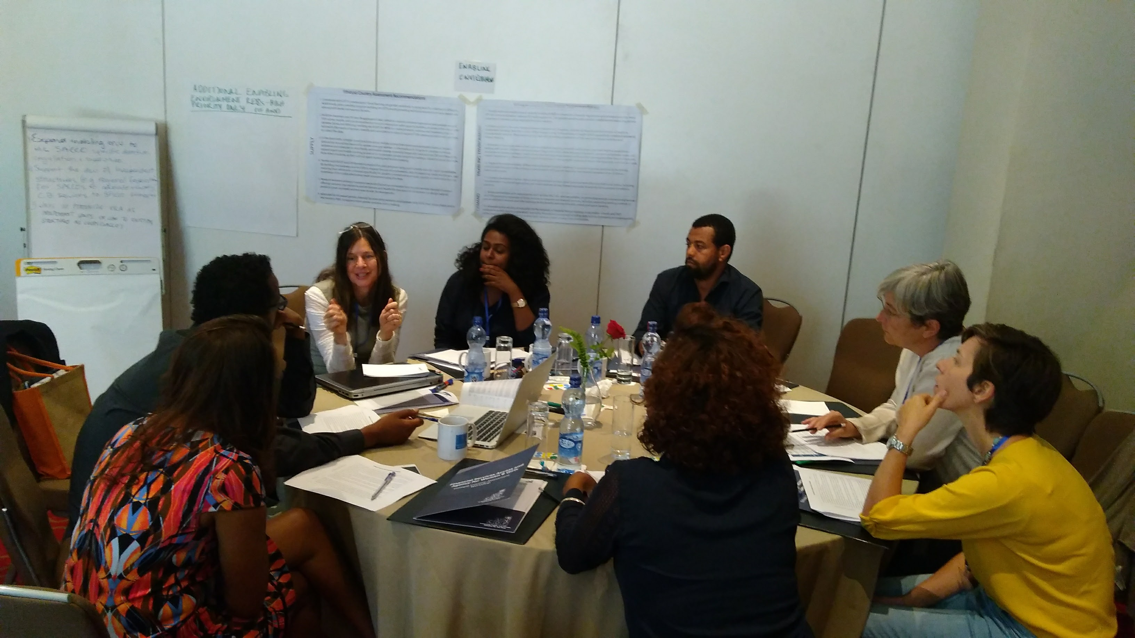

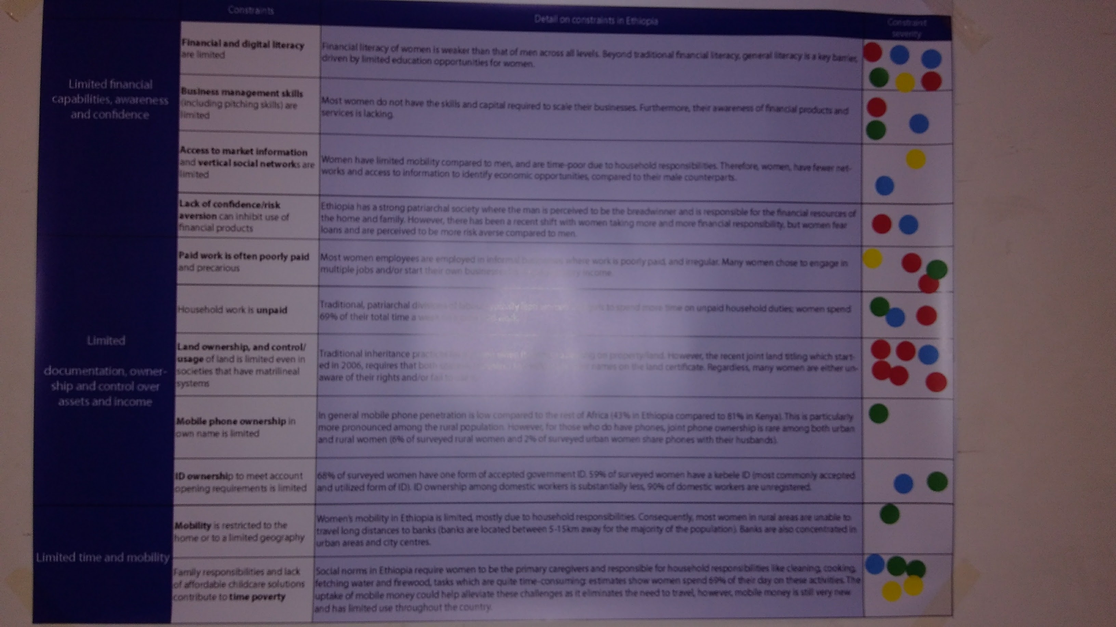

Interactive Activity #2: Prioritisation and Discussion of Identified Recommendations
Building on the key constraints identified for each of the three spheres, Ms. Porter explained that UNCDF developed several recommendations to address each of these constraints. Participants were divided in three (3) groups and asked to reflect on the recommended actions—and complement or add to them as needed, and prioritize the proposed recommendations. One participant from each group was then invited to present the results of the discussions to the audience. The main findings of the plenary discussion are listed below.

DEMAND SIDE
- There is a need of aggressive campaign to increase financial literacy among women taking in to consideration the challenges in mobility. Learning from the teaching of the health sector, use of existing structure like development agents and community leaders needs to be worked on. In urban settings, there is also a need of taking the campaign to kebele level.
- Since Women are close to Ekub and Edir , acknowledging the effort of these groups and formalising will help address the financial need of women
- The land co-ownership of women with their male partners needs to be strengthened.
- Access to an up-to-date market prices for the faming community will also help the financial conditions of women and girls.
- Assisting women and girls to come up with fundable business plan

SUPPLY SIDE
- Eder and Equb needs to be promoted and acknowledged
- Leaning towards building female friendly agent network
- Social norms of society around finical management needs to be worked on
- Impact assessment of the financial institutions should be regulated. Banks and other financial institutions run for profit and they miss their social responsibility
- Having more women employees in the financial institutions will also help in bridging the gap.
- The policy making and implementations should also be looked into. The ways and strategies the policies are implemented need to be looked at.
- NBE has decided that they will spend 3% of their income on financial literacy which should also needs to consider women and young girls.
- R&D for financial institutions should be focused on and funded. Data needs be
collected accordingly and segregated

ENABLING ENVIRONMENT
- SACCOs needs to be strengthened and made more independent to be able to advocate
- Ways to formalise VSLA and a way to control their service
- Gender indicator needs to be included in the NBE’s policy. The outreach of banks is increasing but they are not addressing to the need of women.
- Listen to the grass root level to work on bottom up communication. Both women and men lack know-how about the enabling environment. That needs to be worked on.
- There is a gender strategy which is 20 years old and that is not also a policy. There is a need of proper policy and implementation.
- Involvement of all sectorial ministries in financial inclusion is important.

Closing
At the end of the workshop, all the participants were thanked for their contribution and feedback on the country assessment and their contributions to the design of the UNCDF strategy in Ethiopia and invited to engage further in partnering with UNCDF to advance the economic empowerment of women and girls in Ethiopia through financial inclusion.

Annex 1- Agenda

Time | Agenda Item
8:30 am | Registration
9:00 am | Welcome and overview  Eyob Tesfaye, Program Director Financial Inclusion, UNCDF
9:10 am | Introduction to the UNCDF PoWER Strategy  Beth Porter, Policy Advisor, Financial Inclusion, UNCDF
9:30 am | Country Assessment findings followed by Q&A  Herma Gebru, Dalberg Global Advisors
10:30 am | Coffee Break
10:45 am | Prioritisation of constraints to women’s and girls’ financial inclusion
11:05 am | Discussions on prioritizing UNCDF recommendations to address each of the identified constraints
11:45 am | Plenary feedback on the results of subgroup discussions
12:15 pm | Closing remarks  Beth Porter, Policy Advisor, Financial Inclusion, UNCDF
12:30 pm | Lunch

Annex 2- List of Participants (still waiting for it )

